Multi-Turn AI Chatbot with LLaMA 3

Project Domain / Category
Artificial Intelligence / Natural Language Processing / Conversational AI

Functional Requirements:

PHASE 3: Analytics System

FR14: Data Retrieval for Analytics
- The system shall fetch stored session data from the database for analysis.

FR15: Topic Classification
- The system shall classify messages into domains:
  - Machine Learning
  - Deep Learning
  - Healthcare AI
  - Power Systems
  - E-commerce AI

FR16: Session Segmentation
- The system shall divide sessions into:
  - Start phase
  - Middle phase
  - End phase

FR17: Core Metric Computation
- The system shall compute:
  - Accuracy per reply
  - Accuracy per topic
  - Accuracy per phase
  - Response time statistics
  - Rating averages
  - Length distribution

FR18: Correctness Evaluation
- The system shall calculate:
  - Correct replies count
  - Partially correct replies count
  - Incorrect replies count
  - Overall correctness percentage

FR19: Table Generation
- The system shall generate analytical tables:
  - Topic vs accuracy
  - Reply correctness table
  - Phase-wise accuracy
  - Response time summary
  - Rating distribution
  - Length preference

FR20: Graph Generation
- The system shall generate visual graphs:
  - Topic distribution (pie chart)
  - Accuracy per topic (bar chart)
  - Accuracy vs phase (line graph)
  - Correctness per reply (bar chart)
  - Response time trend (line graph)
  - Rating distribution (bar chart)
  - Length preference (pie chart)

FR21: Dashboard Display
- The system shall display analytics dashboard including:
  - Tables
  - Graphs
  - Session-level insights
  - Topic-based performance

FR22: Session Termination
- The system shall end the session and store the final analytics summary permanently.
Phase 3 Work FLow Chart:
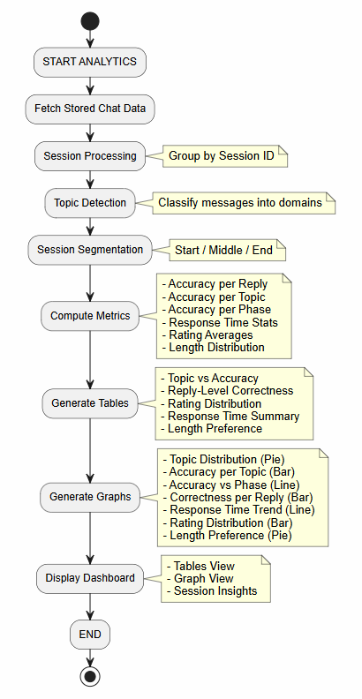
Tools:
- Python – Free and open-source programming language used for backend development, chatbot logic, and analytics.
- LLaMA 3 – Free/open-source large language model used as the core chatbot engine for generating responses locally.
- Flask / FastAPI – Free and open-source Python web frameworks used to build backend APIs and manage chatbot requests.
- HTML, CSS, JavaScript – Standard web technologies for building the chatbot user interface.
- MongoDB / Firebase – Free-tier cloud databases used for storing chat logs, sessions, and feedback data.
- pandas – Open-source Python library used for data processing and analytics.
- matplotlib / seaborn / plotly – Open-source libraries used for generating graphs and visual analytics.
- scikit-learn – Open-source machine learning library used for topic classification and analytics support.
- Ollama (optional) – Free tool used to run LLaMA 3 locally and serve it as an API.
- Google OAuth 2.0 – Free authentication system used for secure Gmail login integration.
- VS Code / Jupyter Notebook – Free development environments used for coding, testing, and experimentation.
- Git & GitHub – Free version control system used for project management and collaboration.

Instructions to Submit:
1. Extend Phase (1&2) developed project by adding this phase’s function requirements.
2. Submission on LMS:
1. Check other Final Report and Presentationfile requirements in Phase 3 folder. Prepare it according to full project(Complete Project Proposal that you receive in start of project(or combined all three phases work).
2. Make a zip file of developed project
3.Combine final report, presentation file and zip project in a folder and submit it on LMS(if folder size exceeds then compress folder to reduce size).
3. A final Viva will be conducted after this phase.

Supervisor:
Name: Neelam Alam
Email ID: neelam.alam@vu.edu.pk
Skype ID: neelam-cs

